**Hands on 1**

**Create a Spring Web Project using Maven**

**SpringLearnApplication.java:**

package com.cognizant.spring_learn;

import org.slf4j.Logger;

import org.slf4j.LoggerFactory;

import org.springframework.boot.SpringApplication;

import org.springframework.boot.autoconfigure.SpringBootApplication;

@SpringBootApplication

public class SpringLearnApplication {

private static Logger LOGGER = LoggerFactory.getLogger ( SpringLearnApplication.class);

public static void main(String[] args) {

SpringApplication.run(SpringLearnApplication.class, args);

LOGGER.info("inside main");

}

}

**Output:**

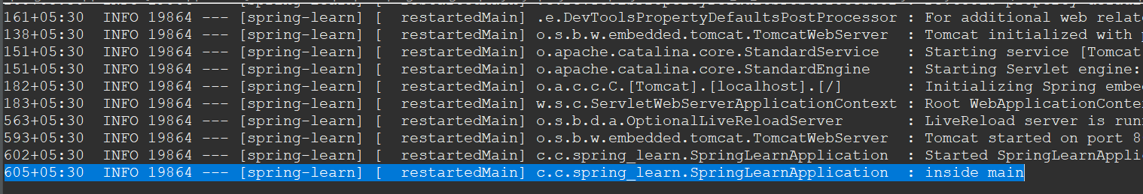

2025-07-07T17:10:42.605+05:30 INFO 19864 --- [spring-learn] [ restartedMain] c.c.spring_learn.SpringLearnApplication : inside main

**Hands on 2**

**Spring Core – Load SimpleDateFormat from Spring Configuration XML**

**SpringLearnApplication.java:**

package com.cognizant.spring_learn;

import java.text.ParseException;

import java.text.SimpleDateFormat;

import org.slf4j.Logger;

import org.slf4j.LoggerFactory;

import org.springframework.boot.SpringApplication;

import org.springframework.boot.autoconfigure.SpringBootApplication;

import org.springframework.context.ApplicationContext;

import org.springframework.context.support.ClassPathXmlApplicationContext;

*@SpringBootApplication*

public class SpringLearnApplication {

private static Logger LOGGER = LoggerFactory.*getLogger* (SpringLearnApplication.class);

public static void main(String[] args) {

SpringApplication.*run*(SpringLearnApplication.class, args);

LOGGER.info("inside main");

*displayDate*();

}

public static void displayDate() {

ApplicationContext context = new ClassPathXmlApplicationContext("date-format.xml");

SimpleDateFormat format = context.getBean("dateFormat", SimpleDateFormat.class);

try {

System.***out***.println("Date: "+format.parse("31/12/2018"));

}

catch(ParseException e) {

System.***out***.println("Cannot Parse Strign into Date");

}

}

}

**Output:**

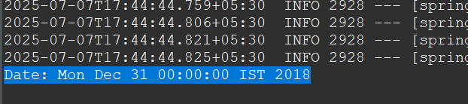

**Hands on 3**

**Spring Core - Incorporate Logging**

**SpringLearnApplication.java:**

package com.cognizant.spring_learn;

import java.text.ParseException;

import java.text.SimpleDateFormat;

import java.util.Date;

import org.slf4j.Logger;

import org.slf4j.LoggerFactory;

import org.springframework.boot.SpringApplication;

import org.springframework.boot.autoconfigure.SpringBootApplication;

import org.springframework.context.ApplicationContext;

import org.springframework.context.support.ClassPathXmlApplicationContext;

*@SpringBootApplication*

public class SpringLearnApplication {

private static final Logger ***LOGGER*** = LoggerFactory.*getLogger* (SpringLearnApplication.class);

public static void main(String[] args) {

SpringApplication.*run*(SpringLearnApplication.class, args);

***LOGGER***.info("inside main");

*displayDate*();

}

public static void displayDate() {

***LOGGER***.info("START");

ApplicationContext context = new ClassPathXmlApplicationContext("date-format.xml");

SimpleDateFormat format = context.getBean("dateFormat", SimpleDateFormat.class);

Date date;

try {

date=format.parse("31/12/2018");

***LOGGER***.debug(date.toString());

}

catch(ParseException e) {

System.***out***.println("Cannot Parse Strign into Date");

}

***LOGGER***.info("END");

}

}

**Output:**  
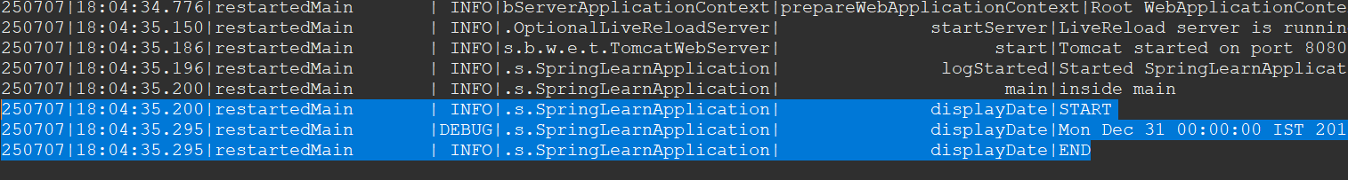

250707|18:04:35.200|restartedMain | INFO|.s.SpringLearnApplication| displayDate|START

250707|18:04:35.295|restartedMain |DEBUG|.s.SpringLearnApplication| displayDate|Mon Dec 31 00:00:00 IST 2018

250707|18:04:35.295|restartedMain | INFO|.s.SpringLearnApplication| displayDate|END

**Hands on 4**

**Spring Core – Load Country from Spring Configuration XML**

**Country.xml:**

<?xml version="1.0" encoding="UTF-8"?>

<beans xmlns="http://www.springframework.org/schema/beans"

xmlns:xsi="http://www.w3.org/2001/XMLSchema-instance"

xsi:schemaLocation="http://www.springframework.org/schema/beans

https://www.springframework.org/schema/beans/spring-beans.xsd">

<bean id="country" class="com.cognizant.spring_learn.Country">

<property name="code" value="IN" />

<property name="name" value="India" />

</bean>

</beans>

**Country.java:**

package com.cognizant.spring_learn;

import org.slf4j.Logger;

import org.slf4j.LoggerFactory;

public class Country {

private static final Logger LOGGER = LoggerFactory.getLogger(Country.class);

private String code;

private String name;

public Country() {

LOGGER.debug("Inside Country Constructor.");

}

public String getCode() {

LOGGER.debug("Getting country code: {}", code);

return code;

}

public void setCode(String code) {

LOGGER.debug("Setting country code to: {}", code);

this.code = code;

}

public String getName() {

LOGGER.debug("Getting country name: {}", name);

return name;

}

public void setName(String name) {

LOGGER.debug("Setting country name to: {}", name);

this.name = name;

}

public String toString() {

return "Country [code=" + code + ", name=" + name + "]";

}

}

**SpringLearnApplication.java:**

package com.cognizant.spring_learn;

import org.slf4j.Logger;

import org.slf4j.LoggerFactory;

import org.springframework.boot.SpringApplication;

import org.springframework.boot.autoconfigure.SpringBootApplication;

import org.springframework.context.ApplicationContext;

import org.springframework.context.support.ClassPathXmlApplicationContext;

*@SpringBootApplication*

public class SpringLearnApplication {

private static final Logger ***LOGGER***=LoggerFactory.*getLogger*(SpringLearnApplication.class);

public static void main(String[] args) {

SpringApplication.*run*(SpringLearnApplication.class, args);

***LOGGER***.info("inside main");

*displayCountry*();

}

public static void displayCountry() {

***LOGGER***.info("START");

ApplicationContext context = new ClassPathXmlApplicationContext("country.xml");

Country country = (Country) context.getBean("country", Country.class);

***LOGGER***.debug("Country : {}", country.toString());

***LOGGER***.info("END");

}

}

**Output:**

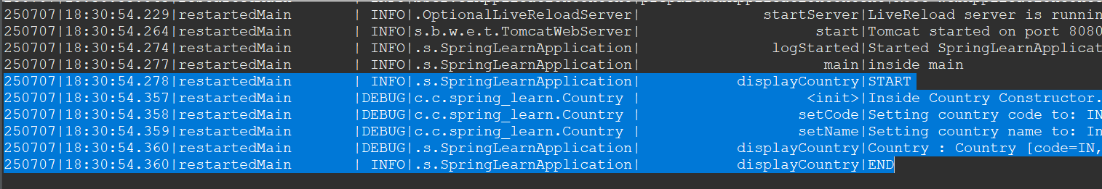

250707|18:30:54.278|restartedMain | INFO|.s.SpringLearnApplication| displayCountry|START

250707|18:30:54.357|restartedMain |DEBUG|c.c.spring_learn.Country | <init>|Inside Country Constructor.

250707|18:30:54.358|restartedMain |DEBUG|c.c.spring_learn.Country | setCode|Setting country code to: IN

250707|18:30:54.359|restartedMain |DEBUG|c.c.spring_learn.Country | setName|Setting country name to: India

250707|18:30:54.360|restartedMain |DEBUG|.s.SpringLearnApplication| displayCountry|Country : Country [code=IN, name=India]

250707|18:30:54.360|restartedMain | INFO|.s.SpringLearnApplication| displayCountry|END

**Hands on 5**

**Spring Core – Demonstration of Singleton Scope and Prototype Scope**

**Singleton Scope:**

**SpringLearnApplication.java:**

package com.cognizant.spring_learn;

import org.slf4j.Logger;

import org.slf4j.LoggerFactory;

import org.springframework.boot.SpringApplication;

import org.springframework.boot.autoconfigure.SpringBootApplication;

import org.springframework.context.ApplicationContext;

import org.springframework.context.support.ClassPathXmlApplicationContext;

*@SpringBootApplication*

public class SpringLearnApplication {

private static final Logger ***LOGGER***=LoggerFactory.*getLogger*(SpringLearnApplication.class);

public static void main(String[] args) {

SpringApplication.*run*(SpringLearnApplication.class, args);

***LOGGER***.info("inside main");

*displayCountry*();

}

public static void displayCountry() {

***LOGGER***.info("START");

ApplicationContext context = new ClassPathXmlApplicationContext("country.xml");

Country country = (Country) context.getBean("country", Country.class);

***LOGGER***.debug("Country : {}", country.toString());

Country anotherCountry = context.getBean("country", Country.class);

***LOGGER***.info("END");

}

}

**Output:**

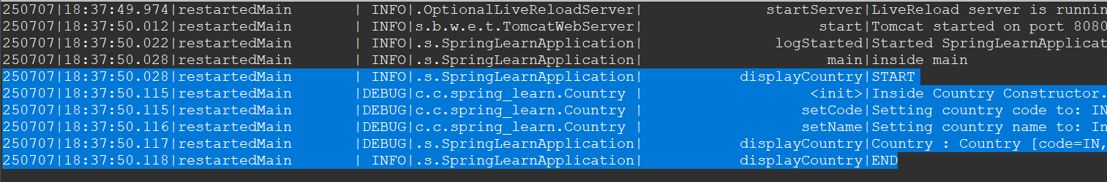

250707|18:37:50.028|restartedMain | INFO|.s.SpringLearnApplication| displayCountry|START

250707|18:37:50.115|restartedMain |DEBUG|c.c.spring_learn.Country | <init>|Inside Country Constructor.

250707|18:37:50.115|restartedMain |DEBUG|c.c.spring_learn.Country | setCode|Setting country code to: IN

250707|18:37:50.116|restartedMain |DEBUG|c.c.spring_learn.Country | setName|Setting country name to: India

250707|18:37:50.117|restartedMain |DEBUG|.s.SpringLearnApplication| displayCountry|Country : Country [code=IN, name=India]

250707|18:37:50.118|restartedMain | INFO|.s.SpringLearnApplication| displayCountry|END

**Prototype Scope:**

**Country.xml:**

<?xml version="1.0" encoding="UTF-8"?>

<beans xmlns="http://www.springframework.org/schema/beans"

xmlns:xsi="http://www.w3.org/2001/XMLSchema-instance"

xsi:schemaLocation="http://www.springframework.org/schema/beans

https://www.springframework.org/schema/beans/spring-beans.xsd">

<bean id="country" class="com.cognizant.spring_learn.Country" scope="prototype">

<property name="code" value="IN" />

<property name="name" value="India" />

</bean>

</beans>

**Output:**

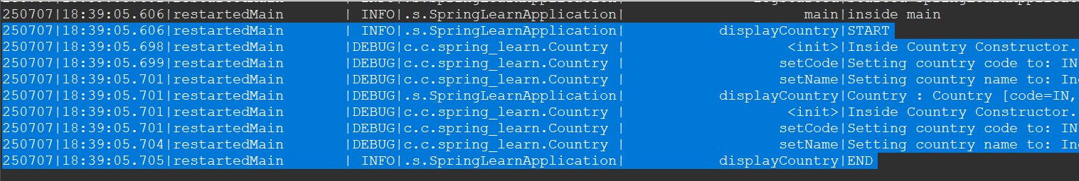

250707|18:39:05.606|restartedMain | INFO|.s.SpringLearnApplication| displayCountry|START

250707|18:39:05.698|restartedMain |DEBUG|c.c.spring_learn.Country | <init>|Inside Country Constructor.

250707|18:39:05.699|restartedMain |DEBUG|c.c.spring_learn.Country | setCode|Setting country code to: IN

250707|18:39:05.701|restartedMain |DEBUG|c.c.spring_learn.Country | setName|Setting country name to: India

250707|18:39:05.701|restartedMain |DEBUG|.s.SpringLearnApplication| displayCountry|Country : Country [code=IN, name=India]

250707|18:39:05.701|restartedMain |DEBUG|c.c.spring_learn.Country | <init>|Inside Country Constructor.

250707|18:39:05.701|restartedMain |DEBUG|c.c.spring_learn.Country | setCode|Setting country code to: IN

250707|18:39:05.704|restartedMain |DEBUG|c.c.spring_learn.Country | setName|Setting country name to: India

250707|18:39:05.705|restartedMain | INFO|.s.SpringLearnApplication| displayCountry|END

**Hands on 6**

**Spring Core – Load list of countries from Spring Configuration XML**

**Country.xml:**

<?xml version="1.0" encoding="UTF-8"?>

<beans xmlns="http://www.springframework.org/schema/beans"

xmlns:xsi="http://www.w3.org/2001/XMLSchema-instance"

xsi:schemaLocation="http://www.springframework.org/schema/beans

https://www.springframework.org/schema/beans/spring-beans.xsd">

<bean id="country" class="com.cognizant.spring_learn.Country" scope="prototype">

<property name="code" value="IN" />

<property name="name" value="India" />

</bean>

<bean id="in" class="com.cognizant.spring_learn.Country">

<property name="code" value="IN"/>

<property name="name" value="India"/>

</bean>

<bean id="us" class="com.cognizant.spring_learn.Country">

<property name="code" value="US"/>

<property name="name" value="United States"/>

</bean>

<bean id="de" class="com.cognizant.spring_learn.Country">

<property name="code" value="DE"/>

<property name="name" value="Germany"/>

</bean>

<bean id="jp" class="com.cognizant.spring_learn.Country">

<property name="code" value="JP"/>

<property name="name" value="Japan"/>

</bean>

<bean id="countryList" class="java.util.ArrayList">

<constructor-arg>

<list>

<ref bean="in"></ref>

<ref bean="us"></ref>

<ref bean="de"></ref>

<ref bean="jp"></ref>

</list>

</constructor-arg>

</bean>

</beans>

**SpringLearnApplication.java:**

package com.cognizant.spring_learn;

import java.util.ArrayList;

import org.slf4j.Logger;

import org.slf4j.LoggerFactory;

import org.springframework.boot.SpringApplication;

import org.springframework.boot.autoconfigure.SpringBootApplication;

import org.springframework.context.ApplicationContext;

import org.springframework.context.support.ClassPathXmlApplicationContext;

*@SpringBootApplication*

public class SpringLearnApplication {

private static final Logger ***LOGGER***=LoggerFactory.*getLogger*(SpringLearnApplication.class);

public static void main(String[] args) {

SpringApplication.*run*(SpringLearnApplication.class, args);

***LOGGER***.info("inside main");

*displayCountries*();

}

public static void displayCountries() {

***LOGGER***.info("START");

ApplicationContext context = new ClassPathXmlApplicationContext("country.xml");

ArrayList<Country> countryList = (ArrayList<Country>) context.getBean("countryList");

***LOGGER***.debug("Country : {}", countryList.toString());

***LOGGER***.info("END");

}

}

**Output:**

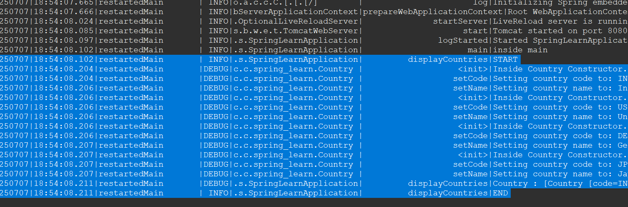

250707|18:54:08.102|restartedMain | INFO|.s.SpringLearnApplication| displayCountries|START

250707|18:54:08.204|restartedMain |DEBUG|c.c.spring_learn.Country | <init>|Inside Country Constructor.

250707|18:54:08.204|restartedMain |DEBUG|c.c.spring_learn.Country | setCode|Setting country code to: IN

250707|18:54:08.206|restartedMain |DEBUG|c.c.spring_learn.Country | setName|Setting country name to: India

250707|18:54:08.206|restartedMain |DEBUG|c.c.spring_learn.Country | <init>|Inside Country Constructor.

250707|18:54:08.206|restartedMain |DEBUG|c.c.spring_learn.Country | setCode|Setting country code to: US

250707|18:54:08.206|restartedMain |DEBUG|c.c.spring_learn.Country | setName|Setting country name to: United States

250707|18:54:08.206|restartedMain |DEBUG|c.c.spring_learn.Country | <init>|Inside Country Constructor.

250707|18:54:08.206|restartedMain |DEBUG|c.c.spring_learn.Country | setCode|Setting country code to: DE

250707|18:54:08.207|restartedMain |DEBUG|c.c.spring_learn.Country | setName|Setting country name to: Germany

250707|18:54:08.207|restartedMain |DEBUG|c.c.spring_learn.Country | <init>|Inside Country Constructor.

250707|18:54:08.207|restartedMain |DEBUG|c.c.spring_learn.Country | setCode|Setting country code to: JP

250707|18:54:08.207|restartedMain |DEBUG|c.c.spring_learn.Country | setName|Setting country name to: Japan

250707|18:54:08.211|restartedMain |DEBUG|.s.SpringLearnApplication| displayCountries|Country : [Country [code=IN, name=India], Country [code=US, name=United States], Country [code=DE, name=Germany], Country [code=JP, name=Japan]]

250707|18:54:08.211|restartedMain | INFO|.s.SpringLearnApplication| displayCountries|END